
It is a…
It lives in/on/under…
It likes…..
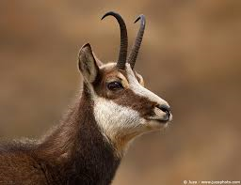
It is a…
It lives in/on/under…
It likes…..

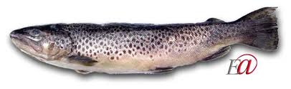
It is a…
It lives in/on/under…
It likes…..

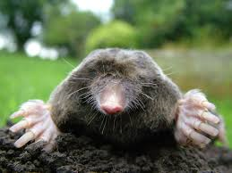
It is a…
It lives in/on/under…
It likes…..
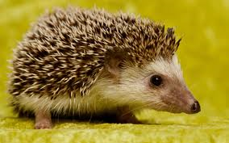
It is a…
It lives in/on/under…
It likes…..


It is a…
It lives in/on/under…
It likes…..

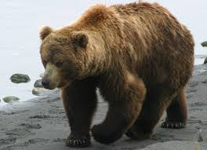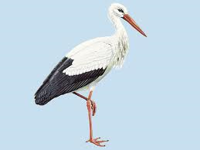
It is a…
It lives in/on/under…
It likes…..


It is a…
It lives in/on/under…
It likes…..

It is a…
It lives in/on/under…
It likes…..

