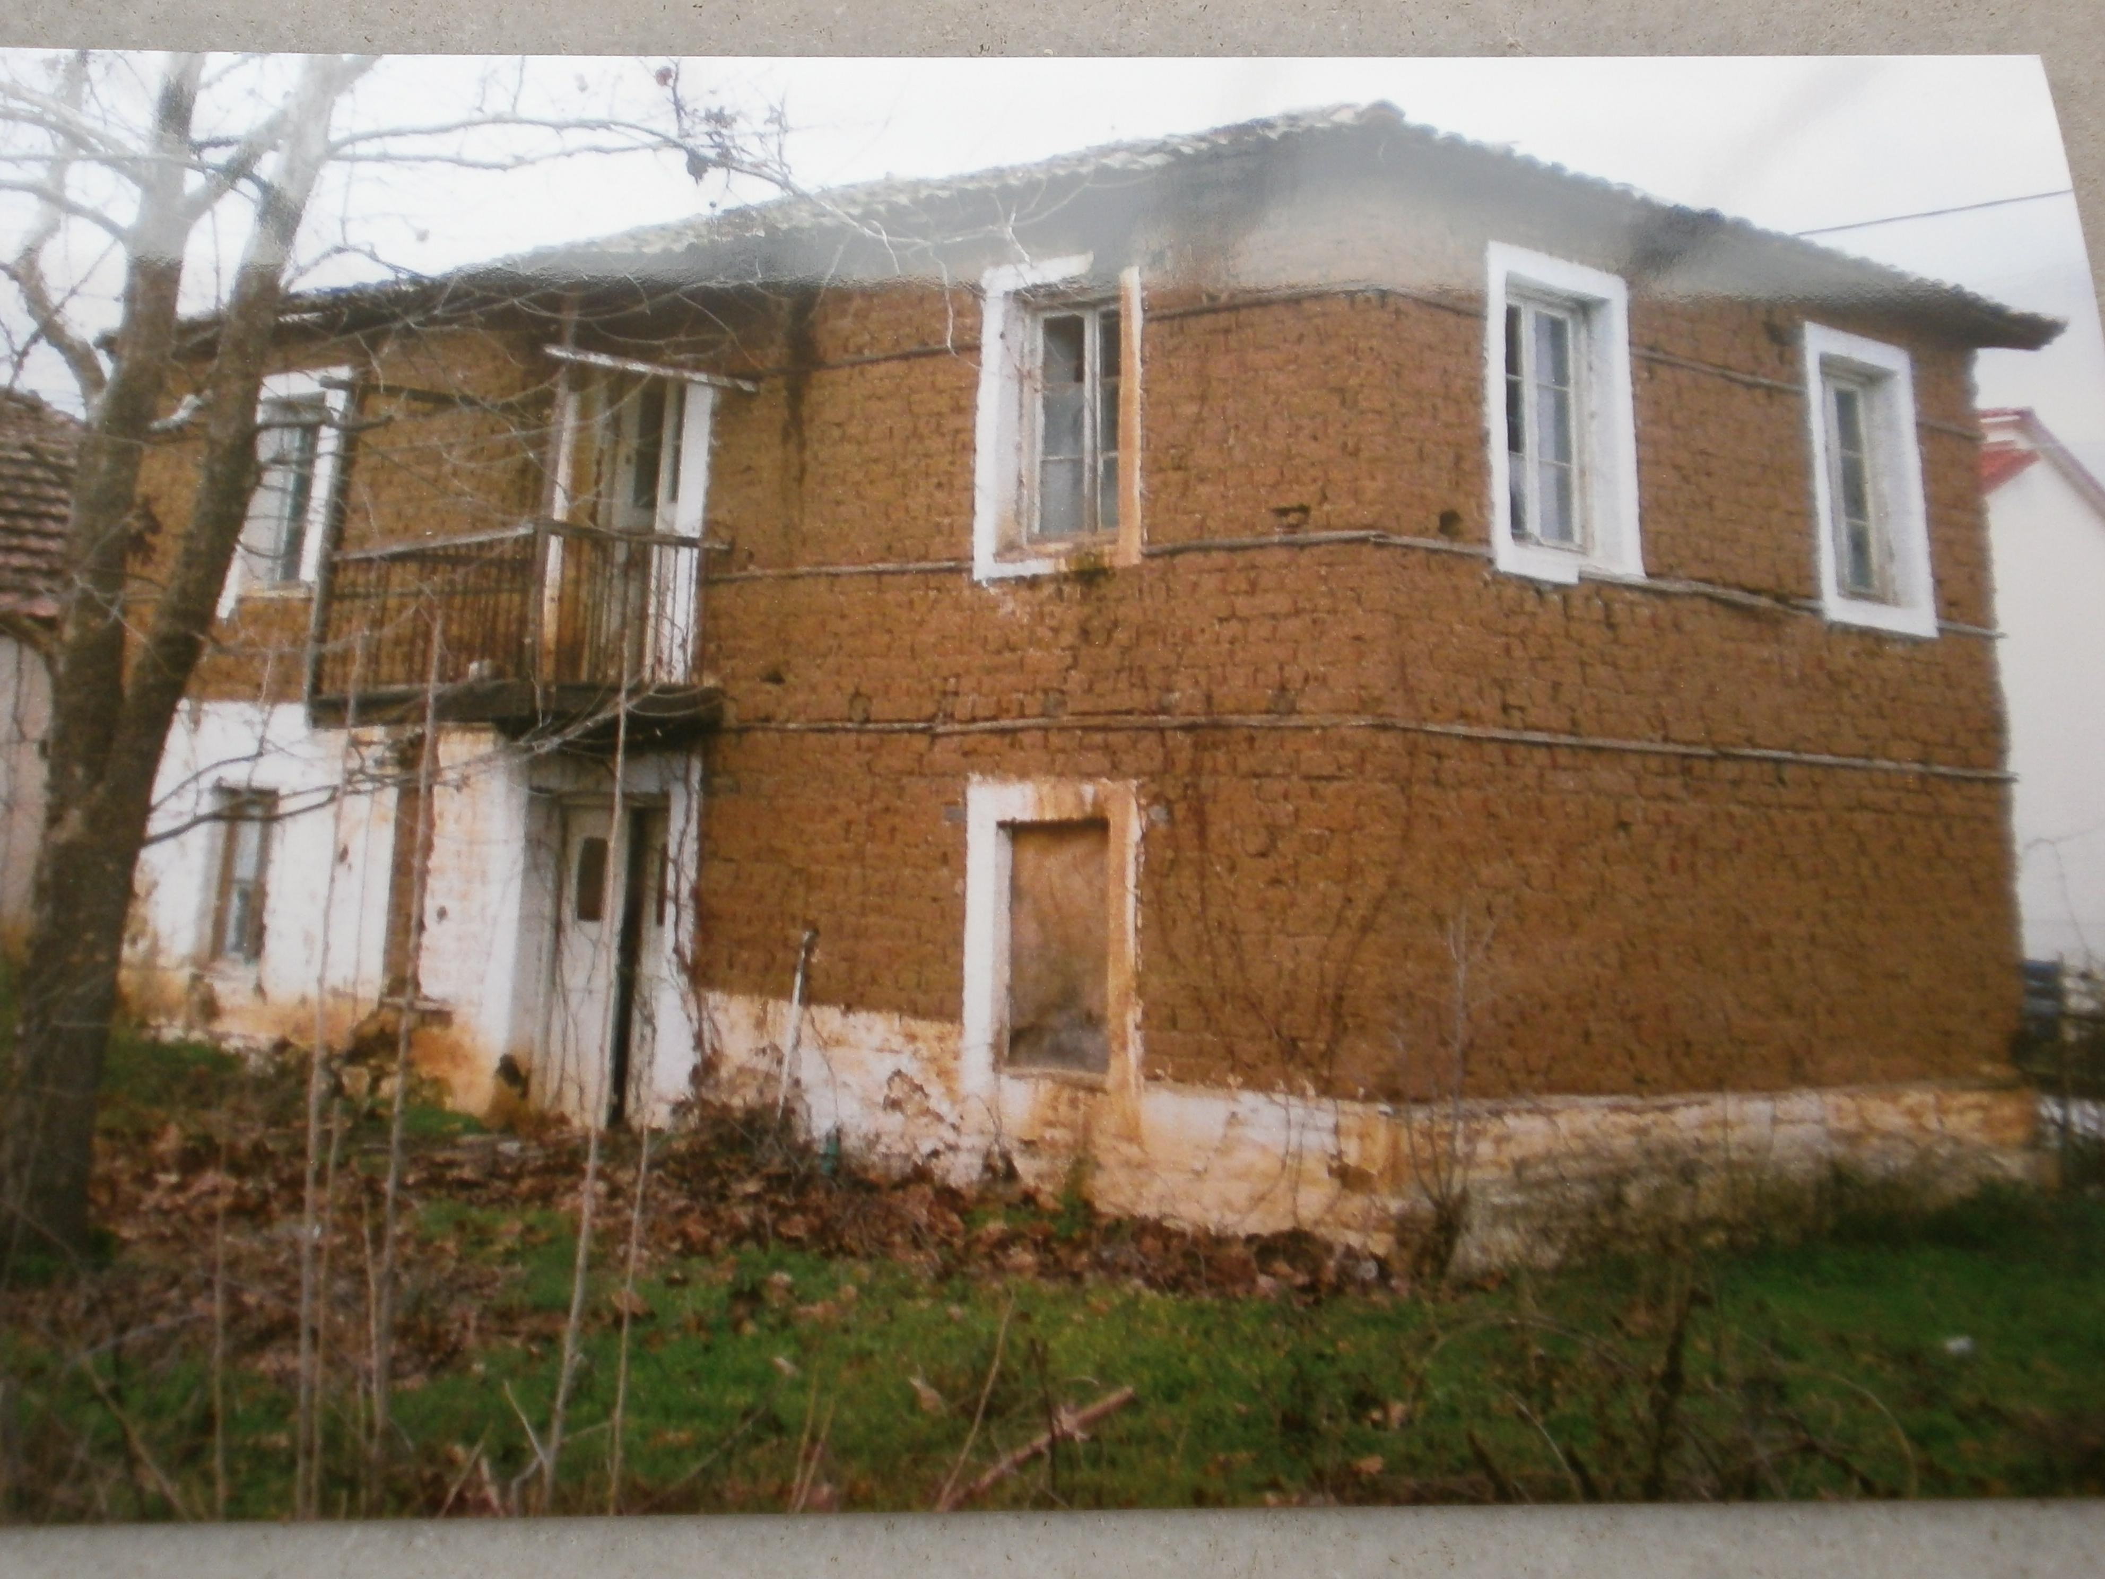
Is this house old or new?
Where is it from?

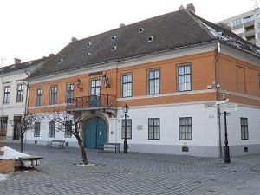
Is this house old or new?
Where is it from?

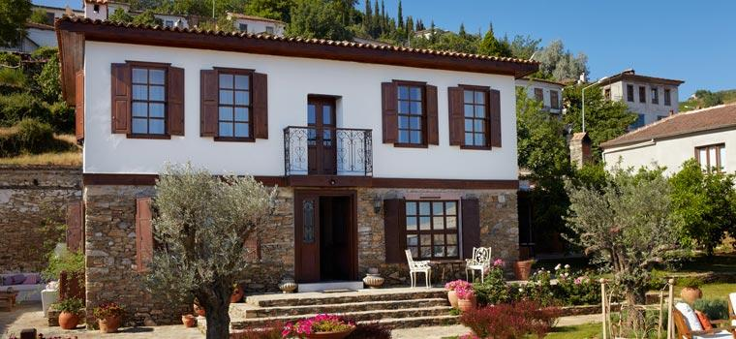
Is this house old or new?
Where is it from?

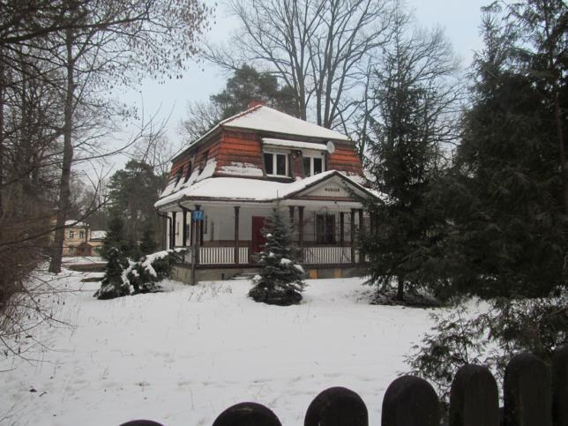
Is this house old or new?
Where is it from?

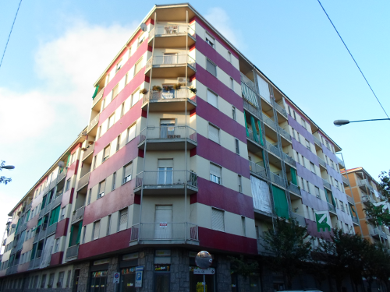
Is this house old or new?
Where is it from?

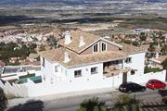
Is this house old or new?
Where is it from?

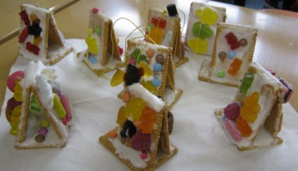
What is it?
What is it made of?
Where is it from?

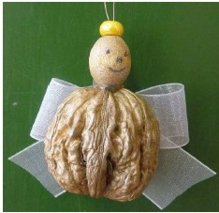
What is it?
What is it made of?
Where is it from?

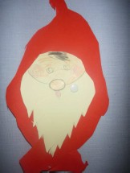
What is it?
What is it made of?
Where is it from?

